A Brighton Collaboration standardized template with key considerations for a benefit/risk assessment for the Clover COVID-19 recombinant protein vaccine to prevent disease caused by SARS-CoV-2 viruses

Xuesong Peiª, Nicolas Burdinª, Htay Htay Hanª, Yang Liª, Wei Tanª, Chuanna Douª, Emily R. Smith ^{b*}, Marc Gurwith ^{b}, Robert T. Chen ^{b}
For the Benefit-Risk Assessment of VAccines by TechnolOgy Working Group (BRAVATO; ex-V3SWG) ¹

ª Clover Biopharmaceuticals, Beijing, China
^{b} Brighton Collaboration, a program of the Task Force for Global Health, Decatur, GA, USA

*Corresponding author: email address: bc-coordinator@taskforce.org
- See Acknowledgement for other BRAVATO members.

Keywords:
COVID-19 Vaccine, Protein Vaccine Safety, Vaccine Benefit/Risk, Coronavirus, SARS-CoV-2, Vaccine Immunogenicity, Vaccine Efficacy

Abstract:
Background:
We evaluated the safety, immunogenicity and efficacy of SCB-2019, a protein subunit vaccine candidate containing a recombinant SARS-CoV-2 spike (S) trimer fusion protein, combined with CpG-1018/alum adjuvants.
Methods:
This ongoing phase 2/3, double-blind, placebo-controlled, randomized trial is being conducted in Belgium, Brazil, Colombia, the Philippines, and South Africa in participants ≥ 12 years of age. Participants were randomly assigned to receive 2 doses of SCB-2019 or placebo administered intramuscularly 21 days apart. Here, we present the safety, immunogenicity and efficacy results of SCB-2019 over the 6-month period following 2-dose primary vaccination series in all adult participants (≥18 years of age). A total of 30174 subjects were included in the Randomized set of the study, initially for the Phase 2 and then as part of the Phase 3. In the Efficacy (Dose 1) Full Analysis Set (FAS), the SCB-2019 arm included 14684 subjects, and the Placebo arm included 14670 subjects. In the Efficacy (Dose 2) FAS, the SCB-2019 arm included 12989 subjects, and the Placebo arm included 12823 subjects between 24 March 2021 and 01 December 2021. Unsolicited adverse events, medically-attended adverse events (SAE), adverse events of special interest, and serious adverse events were reported in similar frequencies in both study arms over the 6-month follow-up period. [1] [2]
Results:
Vaccine-related SAEs were reported by 4 of 15,070 SCB-2019 recipients (hypersensitivity reactions in two participants, Bell’s palsy, and spontaneous abortion) and 2 of 15,067 placebo recipients (COVID-19, pneumonia, and acute respiratory distress syndrome in one participant and spontaneous abortion in the other one). No signs of vaccine-associated enhanced disease were observed.
1601 individuals were enrolled between 24 March and 13 September 2021 and received at least one vaccine dose. Immunogenicity analysis was conducted in a phase 2 subset of 691 participants, including 428 SARS-CoV-2-naïve (381 vaccine and 47 placebo recipients) and 263 SARS-CoV-2-exposed (235 vaccine and 28 placebo recipients). In SARS-CoV-2-naïve participants, GMTs of neutralizing antibodies against prototype virus increased 2 weeks post-second dose (day 36) compared to baseline (224 vs 12.7 IU/mL). Seroconversion rate was 82.5 %. In SARS-CoV-2-exposed participants, one SCB-2019 dose increased GMT of neutralizing antibodies by 48.3-fold (1276.1 IU/mL on day 22) compared to baseline. Seroconversion rate was 92.4 %. Increase was marginal post-second dose. SCB-2019 also showed cross neutralization capability against nine variants, including some Omicron strains, in SARS-CoV-2-exposed participants at day 36. SCB-2019 stimulated Th1-biased cell-mediated immunity to the S-protein in both naïve and exposed participants. The vaccine was well tolerated, no safety concerns were raised from the study. [3]
There were 207 confirmed per-protocol cases of COVID-19 at 14 days after the second dose, 52 vaccinees versus 155 placebo recipients, and an overall vaccine efficacy against any severity COVID-19 of 67·2% (95·72% CI 54·3–76·8), 83·7% (97·86% CI 55·9–95·4) against moderate-to-severe COVID-19, and 100% (97·86% CI 25·3–100·0) against severe COVID-19. All COVID-19 cases were due to virus variants; vaccine efficacy against any severity COVID-19 due to the three predominant variants was 78·7% (95% CI 57·3–90·4) for delta, 91·8% (44·9–99·8) for gamma, and 58·6% (13·3–81·5) for mu. [2]
Conclusions:
SCB-2019 administered as a 2-dose series has an acceptable safety profile. No safety concerns were identified during the 6-month follow-up after the primary vaccination. [4] A single dose of SCB-2019 was immunogenic in SARS-CoV-2-exposed individuals, whereas two doses were required to induce immune response in SARS-CoV-2-naïve individuals. SCB-2019 elicited a cross-neutralizing response against emergent SARS-CoV-2 variants at antibody levels associated with clinical protection, underlining its potential as a booster. [3] Two doses of SCB-2019 vaccine plus CpG and alum provides notable protection against the entire severity spectrum of COVID-19 caused by circulating SAR-CoV-2 viruses, including the predominating delta variant. [2]

1. Introduction
The Brighton Collaboration (www.brightoncollaboration.org) Viral Vector Vaccine Safety Working Group (V3SWG) was formed in 2008 in recognition of the increasing importance of viral vectors for the development of new vaccines and the need to understand their associated safety issues. [5] To better meet the needs of many other platform technologies used to develop vaccines to prevent COVID-19 beyond just vaccines using viral vectors, the V3SWG was renamed to Benefit-Risk Assessment of VAccines by TechnolOgy (BRAVATO) Working Group in July 2020. The BRAVATO WG has developed standardized templates to describe the key characteristics of several major vaccine platform technologies, including protein vaccines. [6] When completed (usually in a partnership between BRAVATO WG and the vaccine developer), the BRAVATO template helps answer key questions on the essential safety and benefit-risk issues of the intrinsic properties of the candidate vaccine to facilitate scientific discourse among key stakeholders. [7] The World Health Organization (WHO) Global Advisory Committee on Vaccine Safety (GACVS) has endorsed the use of the template “as it is a structured approach to vaccine safety”. [8, 9]
This paper uses a BRAVATO protein template to review the features of Clover’s recombinant adjuvanted spike protein vaccine to prevent disease caused by SARS-CoV-2 viruses.

2. Background
The virus 2019-nCoV was identified as the causative agent of a worldwide outbreak of pneumonia-like respiratory disease following reports of unexplained pneumonia cases in Wuhan, Hubei Province, China in December 2019. Phylogenetic studies reported that the virus is 79% and 50% homologous to severe acute respiratory syndrome coronavirus (SARS-CoV) and Middle East respiratory syndrome coronavirus (MERS-CoV), respectively, [10] two previously identified coronaviruses that have also caused life-threatening respiratory disease worldwide. The virus was categorized in the betacoronavirus subfamily and thereafter renamed as SARS-CoV-2, and the disease caused by the virus became known as coronavirus disease 2019 (COVID-19). [11] As of late November 2022, more than 637 million confirmed cases and over 6.6 million deaths due to COVID-19 have been reported globally. [12] People infected with SARS-CoV-2 present with various degrees of clinical manifestation and disease severity, ranging from asymptomatic to severe or even fatal illness. [13] In order to confront the COVID-19 pandemic, a variety of vaccines had been developed against SARS-CoV-2 around the world including messenger ribonucleic acid (mRNA), deoxyribonucleic acid (DNA), non-replicating viral vector, inactivated virus, and protein subunit technologies. [14] [15] Subunit vaccines contain only the antigenic portion of the pathogen that is necessary to induce a protective immune response. A number of subunit vaccines against SARS-CoV are under development using the full-length S protein, the receptor binding domain (RBD), non-RBD S protein fragments, and non-S structural proteins. [16] SARS-CoV-2 has 79.6% genomic sequence homology with SARS-CoV and the sequences encoding the open reading frame of the 4 structural proteins consisting of S (spike), E (envelope), M (membrane), and N (nucleocapsid), plus 6 accessory proteins have been characterized. [17]
The SARS-CoV-2 virus gains entry into the host cells following structural changes of the densely glycosylated S protein that allow fusion of the viral membrane with the host cell membrane, resulting in viral infection. [18] [19] The S protein of SARS-CoV-2 is a trimeric class I fusion protein that exists in a metastable prefusion conformation. It contains three segments: a large ectodomain, a transmembrane domain, and a cytoplasmic tail. The ectodomain consists of two functional subunits, an S1 subunit responsible for binding to the host cell receptor and an S2 subunit for fusion of the viral and cellular membranes. [20] S1 subunit binds to the angiotensin-converting enzyme 2 (ACE2) receptors, [17] [21] which are expressed abundantly in lung and small intestine cells. [22] The S protein, the major antigenic determinant of SARS-CoV-2, has two major conformational states, prefusion and post-fusion. [23] It is crucial for a vaccine to incorporate an antigen in the correct conformation to effectively generate the appropriate antibody-mediated immune response.
Trimer-Tag (Clover Biopharmaceuticals, Chengdu, China) is derived from the C-terminal region of human type I procollagen and is capable of self-trimerisation. [14] When target proteins are fused in-frame to Trimer-Tag, the resulting fusion proteins expressed in mammalian cells are secreted as disulfide bond-linked homotrimers. S-Trimer is a recombinant SARS-CoV-2 Spike-Trimer-Tag fusion protein produced in Chinese hamster ovary cells. It preserves the native trimeric structure of S-protein in the prefusion conformation with the antigenic epitopes, which is necessary to induce high-titer neutralizing antibodies, and it binds with high affinity to human ACE2. [15] S-Trimer was highly purified via multiple steps, including removal of host cell proteins, residual DNA, and preventative viral inactivation agents, to meet International Council for Harmonization (ICH) guidelines. The resulting vaccine candidate, SCB-2019, is stable liquid solution formulations at 2–8°C for at least 6 months, with longer term stability studies ongoing. [24]
SCB-2019 is formulated with 2 adjuvants, namely CpG 1018, developed by Dynavax Technologies (Emeryville, CA, USA), (a 22-mer CpG-enriched oligodeoxynucleotide [ODN] phosphorothioate) and Al(OH)3. Upon internalization into cells, the unmethylated CpG sequences are recognized as foreign and bind to toll-like receptor 9 (TLR9), expressed in plasmacytoid dendritic cells (pDCs) and B cells. This interaction activates the antigen presenting pDCs and B cells and thereby induces innate and adaptive immune responses. [25] [26] Aluminum adjuvant has been widely used in vaccines based on its ability to enhance antibody-mediated immune response. [27] The combination of immunostimulatory molecules with aluminum adjuvant could potentiate cell-mediated immune response. [28] CpG ODN was shown to induce cytotoxic T cell response and enhance the antibody-mediated response to hepatitis B antigen in mice and in human when formulated with Al(OH)3. [29] [30]
3. Disclaimer
The findings, opinions, conclusions, and assertions contained in this consensus document are those of the authors. They do not necessarily represent the official positions of any participant’s organization (e.g., government, university, or corporations) and should not be construed to represent any Agency determination or policy.
4. Acknowledgements
The clinical study was funded by Clover Biopharmaceuticals and the Coalition for Epidemic Preparedness Innovations (CEPI). We thank the participants in the trial and clinical team members at Clover Biopharmaceuticals, and our external service providers (contract research organizations, laboratories, clinical suppliers, and biostatistics providers) for their invaluable assistance in the trial. We also thank Dynavax Technologies for providing the CpG 1018 adjuvant. We are grateful to the Scientific Advisory Board members and CEPI team for their advice and guidance, to the members of the data and safety monitoring board for their dedication to the trial, and to the endpoint adjudication committee for their expert analysis of the trial data.
5. Declaration of interests
The Brighton Collaboration BRAVATO authors declare that they have no known competing financial interests or personal relationships that could have appeared to influence the work reported in this paper. XP, NB, TTH, WT are full-time employees of Clover Biopharmaceuticals.
Brighton Collaboration
Standardized Template for Collection of Key Information for the Benefit-Risk Assessment of Protein Vaccines
1. Authorship | Information
1.1 Author(s) and affiliation(s) | Xuesong Pei
1.2 Date completed/updated | 20-03-2024
2. Basic Vaccine information | Information | Comments/Concerns
2.1 Vaccine name | SCB‑2019 Vaccine [Recombinant SARS‑CoV‑2 Subunit Vaccine (CHO Cell)]
2.2 Protein type (e.g., molecular clamp, virus-like particle, peptide) and any special characteristics | Recombinant SARS-CoV-2 Spike [S]-Trimer Fusion Protein of the original Wuhan‑Hu‑1 strain, which utilizes Trimer‑Tag™ technology to preserve the native trimeric structure of S‑protein in the prefusion form.
2.3 Type of heterologous expression system used for antigen production (e.g., bacteria, yeast, plants, mammalian or insect cells, chemical synthesis) | Chinese hamster ovary (CHO) cells
2.4 Adjuvant (if applicable) | CpG1018 + Alum Alhydrogel
2.5 Final vaccine formulation components that may impact delivery into cells, stability, and safety (e.g., preservatives (e.g., thimerosal, phenol, benzethonium chloride, 2-phenoxyethanol), complexing with polymers, encapsulation within microparticles, liposomes, depot formulations) | Component Nominal Quantity (per 0.5 mL dose)  SCB‑2019 antigen 30 µg  Aluminium content as aluminium hydroxide 0.75 mg  CpG 1018 1.5 mg  Sodium dihydrogen phosphate monohydrate 0.026 mg  Disodium hydrogen phosphate dihydrate 0.026 mg  Sodium chloride 3.430 mg  Polysorbate 80 0.013 mg  Tris (hydroxymethyl) aminomethane 0.303 mg  Hydrochloric acid ¹ 0.203 mg
2.6 Route and method of delivery (e.g., intramuscular injection, microneedles, skin patch, intranasal, other mucosal) | Intramuscular (IM) injection at the deltoid region of the upper arm
3. Target Pathogen and Population | Information | Comments/Concerns
3.1 What is the target pathogen? | SARS-CoV-2 virus [31]
3.2 What are the disease manifestations caused by the target pathogen in humans, for the following categories:
- In healthy people | People may experience different symptoms from COVID-19. Symptoms usually begin 5–6 days after exposure and last 1–14 days. Clinical presentation of COVID-19 infection may vary from asymptomatic to severe and fatal. Most of the patients are asymptomatic, The most common symptoms include fever, cough, and shortness of breath. Some patients may experience gastrointestinal symptoms including vomiting, diarrhea, and abdominal pain. Patients may also experience symptoms, including expectoration, fatigue and headache or dizziness, hyposmia. Less common symptoms include anorexia, dysgeusia, conjunctivitis, and skin lesions. [32]
- In immunocompromised people | Immunocompromised are more likely to get sick with COVID-19 and at risk of prolonged infection Patients may at increased risk of severe disease and mortality. [33]
- In neonates, infants, children | Infection in children can lead to severe disease. The most common symptoms are cough and fever. Older children are also more likely to present with symptoms such as vomiting, abdominal pain, headache, sore throat, and loss of taste and smell. Most of the severe and critical cases occurred in children with underlying conditions and immunosuppression. [34]
- During pregnancy and in the fetus | Pregnant women are at increased risk of severe illness with COVID-19. They might need to be hospitalized, have intensive care or be placed on a ventilator to help with breathing. Pregnant women with COVID-19 are also more likely to deliver a baby before the start of the 37th week of pregnancy (premature birth) and also be at increased risk of stillbirth and pregnancy loss. [35]
- In elderly | Older patients with COVID-19 had more underlying comorbidities and laboratory abnormalities. Had a higher rate of acute respiratory distress syndrome (ARDS), acute cardiac injury and heart failure, had more multi-organ damage and presented more severe with the mortality. [36]
- In any other special populations | People with co-morbidities are more likely to develop severe respiratory disease that requires hospitalization or even die. [37]
3.3 Briefly, what are the key epidemiologic characteristics of the disease caused by the target pathogen (e.g., incubation period, communicable period, route/s of transmission, case fatality rate, transmissibility characteristics such as basic reproductive ratio (R₀), and spontaneous mutation)? | A） Route of transmission:  SARS-CoV-2 can spread through both direct means (droplet and human-to-human transmission) and by indirect contact (contaminated objects and airborne contagion) [38]  - The virus spreads mainly between people who are in close contact with each other, for example at a conversational distance.  - The virus can spread from an infected person’s mouth or nose in small liquid particles when they cough, sneeze, speak, sing or breathe. Another person can then contract the virus when infectious particles that pass through the air are inhaled at short range (this is often called short-range aerosol or short-range airborne transmission) or if infectious particles come into direct contact with the eyes, nose, or mouth (droplet transmission).  - The virus can also spread in poorly ventilated and/or crowded indoor settings, where people tend to spend longer periods of time. This is because aerosols can remain suspended in the air or travel farther than conversational distance (this is often called long-range aerosol or long-range airborne transmission). [39]  B) Incubation period: The average incubation periods of the main variants from the 2022 review study were: Alpha variant: 5.0 days; Beta variant: 4.50 days; Delta variant: 4.41 days; Omicron variant: 3.42 days.  The 2023 COVID strains, including Omicron and its subvariants, appear to be more transmissible because of their shorter incubation period. [40]  C) Fatality indexes:  1. The infection fatality ratio (IFR)  There is no agreement on the amount of IFR for COVID-19, but the best models estimate this index to be 0.5–1%.  2. Case fatality rate (CFR).  The overall CFR value for COVID-19 is 2.3%, 13.8%, 3.8%, 8.2%, and 1.6% in China, Italy, Germany, Spain, and South Korea, respectively. [41]  D) The introductory reproduction rate (R0)： The highest R0 for the variants Alpha (1.22), Beta (1.19), Gamma (1.21), Delta (1.38) and Omicron (1.90) were reported from Japan, Belgium, the United States, France and South Africa, respectively. Nine out of ten epidemic curves with the highest estimated growth rates and reproduction numbers were due to the Omicron variant indicating the highest transmissibility. [42]  E) Latent period: Omicron BA.1 had the shortest pooled estimates for the incubation period (3.49 days, 95% CI: 3.13–4.86 days), Omicron BA.5 for the serial interval (2.37 days, 95% CI: 1.71–3.04 days), and Omicron BA.1 for the realized generation time (2.99 days, 95% CI: 2.48–3.49 days). [43]  F) Mutation status: WHO is currently tracking several SARS-CoV-2 variants: five VOIs – XBB.1.5, XBB.1.16, EG.5 BA.2.86 and JN.1; and five VUMs: DV.7, XBB, XBB.1.9.1, XBB.1.9.2 and XBB.2.3.  JN.1 is exhibiting increasing trends, its parent lineage, BA.2.86, is stable, the other VOIs, XBB.1.5, XBB.1.16 and EG.5, have decreased in global prevalence during the same period. Besides, all VUMs have shown a decreasing trend. There are currently no reported laboratory or epidemiological reports indicating any association between VOIs/VUMs and increased disease severity. [44]
3.4 What sections of the population are most affected by the target pathogen (e.g., pediatric, pregnant, lactating women (breast feeding), adult, elderly) | The World Health Organization (WHO) declared SARS-CoV-2 as a pandemic on March 11, 2020. As of March 23, 2020, there were 362,019 confirmed cases of SARS-CoV-2 reported from 168 different countries, with 15,488 deaths and an overall projected case fatality rate (CFR) of 4.3%. The Centers for Disease Control and Prevention (CDC) reported that although individuals older than age 65 comprise 17% of the total population in the United States, they make up 31% of COVID-19 infections, 45% of hospitalizations, 53% of intensive care unit admissions, and 80% of deaths caused by this infection. This suggests that older individuals are more likely to get COVID-19 and have worse outcomes compared with the general population.[45]
3.5 What is known about the immune responses, duration, and potential correlates of protective immunity to the target pathogen or to the disease? | Immune response: COVID‐19 infection induces IgG antibodies against S protein that can be detected by serum as early as day 4 after the onset of disease and with most patients seroconverting by day 14. Laboratory evidence of clinical patients showed that a specific T‐cell response against SARS‐CoV‐2 is important for the recognition and killing of infected cells, particularly in the lungs of infected individuals.  Based on immunofluorescence assays and ELISA, in 89% of the recovered patients, IgG‐specific and neutralizing antibodies were detected 2 years after SARS infection.  In addition, peak specific IgM on the ninth day after disease and the class switching to IgG in the second week were detected. [46]
3.6 Please describe any other key information about the target pathogen or population that may inform benefit-risk | Comorbidities, including hypertension, diabetes, malignancy, cardiovascular disease, coronary heart disease, cerebrovascular disease, cardiovascular/cerebrovascular disease, chronic obstructive pulmonary disease (COPD), respiratory system disease, chronic kidney disease, hepatitis B infection, and digestive disease were significantly associated with the disease severity. [47]
4. Characteristics of Antigen | Information | Comments/ Concerns
4.1 Is the vaccine likely to induce immunity to all strains/genotypes of the target pathogen? What is the evidence? | The vaccine is cross-protective against D614G mutation SARS-CoV-2 strain, based on the hamster challenge study results which used the mut strain for challenge and VNT assay. Cross protection against SARS-CoV and other common cold coronaviruses are also being evaluated in nonclinical studies. The vaccine antigen is based on the full-length ectodomain spike (S1 and S2 domains), and S2 is more conserved across strains than S1.  The primary objective of the study was met: [1]  - Two doses of SCB-2019 induced protection against COVID-19 of any severity in SARS-CoV-2–naïve adults with an efficacy of 67.2% (95.72% CI: 54.3–76.8).  The pre-specified success criteria were met for three of four key secondary efficacy objectives. [1]  - The efficacy of 2 doses SCB-2019 against moderate-to-severe COVID-19 was 83.7% (97.86% CI 55.9–95.4) in SARS-CoV-2–naïve adults. The pre-specified success criterion (LL of multiplicity-adjusted CI above 0) was met.  - The efficacy of 2 doses SCB-2019 against severe COVID-19 was 100% (97.86% CI 25.3–100.0) in SARS-CoV-2–naïve adults. The pre-specified success criterion (LL of multiplicity-adjusted CI above 0) was met.  - The efficacy of 2 doses SCB-2019 against any laboratory-confirmed SARS-CoV-2 infection was 34.4% (95% CI: 27.1-41.0) in SARS-CoV-2-naïve adults. The pre-specified success criterion (LL of multiplicity-adjusted CI above 0) was met.  - The efficacy of 2 doses SCB-2019 against any laboratory-confirmed asymptomatic SARS-CoV-2 infection was 12.9% (95% CI: -1.4-25.2) in SARS-CoV-2-naïve adults. The pre-specified success criterion (LL of multiplicity-adjusted CI above 0) was not met.  Secondary Efficacy Objective #1 – VE against burden of disease (BOD, the sum of mortality and morbidity is called the “burden of disease”, it can be measured by a metric called “Disability Adjusted Life Years” (DALYs). DALYs are standardized units to measure lost health. They help compare the burden of different diseases in different countries, populations, and times. Conceptually, one DALY represents one lost year of healthy life – it is the equivalent of losing one year in good health because of either premature death or disease or disability.): [1]  - The efficacy of 2 doses SCB-2019 against BOD was 4.9% (95% CI: 40.5-56.0) in SARS-CoV-2-naïve adults, with a BOD score of 260 for SCB-2019 recipients and 509 for placebo recipients.  - The efficacy of 2 doses SCB-2019 against BOD using an alternative score was 51.3% (95% CI: 42.8-58.4) in SARS-CoV-2-naïve adults, with a BOD score of 296 for SCB 2019 recipients and 608 for placebo recipients.  Secondary Efficacy Objective #2 – VE against RT-PCR-confirmed COVID-19 of any severity, associated with hospitalization [1]:  - In SARS-CoV-2–naïve subjects, vaccine efficacy against COVID-19 of any severity, associated with hospitalization was 100% (95% CI 42.7–100).  Secondary Efficacy Objective #3 – VE by evidence of prior SARS-CoV-2 infection and risk of severe COVID-19 [1]:  - In SARS-CoV-2–exposed subjects, vaccine efficacy against COVID-19 of any severity was 64.2% (95% CI 26.5–83.8).  - In SARS-CoV-2–naïve adults at high risk of severe COVID-19, vaccine efficacy against COVID-19 of any severity was 65.9% (95% CI 35.7–82.9).  - In SARS-CoV-2–naive adults at low risk of severe COVID-19, vaccine efficacy against COVID-19 of any severity was 67.9% (95% CI 53.3–78.3).  Secondary Efficacy Objective #4 – VE after the first dose: [1]  - In SARS-CoV-2–naïve subjects, vaccine efficacy against COVID-19 of any severity was 7.8% (95% CI −16.7 to 27.3) from 14 days after Dose 1 through to Dose 2.  - In SARS-CoV-2–exposed subjects in the Efficacy-FAS (Dose 1), vaccine efficacy against COVID-19 of any severity was 49.9% (95% CI 1.5–75.6) from 14 days after Dose 1 through to Dose 2.  Secondary Efficacy Objective #5 – VE against SARS-CoV-2 variants of concern: [1]  - In SARS-CoV-2–naive subjects, vaccine efficacy against COVID-19 of any severity caused by the most frequent lineages of SARS-CoV-2 was 78.7% (95% CI 57.3–90.4) for Delta lineage, 58.6% (95% CI 13.3–81.5) for Mu lineage, and 91.8% (95% CI 44.9–99.8) for Gamma lineage.  In summary, the study was conducted in multiple countries with dominant circulation of various SARS-CoV-2 variants of concerns and variants of interest. SCB-2019 vaccine induces protection against COVID-19 of any severity in individuals with evidence of prior exposure to SARS-CoV-2. [1]
4.2 What is known about the immune response to the vaccine in animals and/or humans (binding, functional, and neutralizing antibody, B-cell, T-cell memory, etc.)? | SCB‑2019 has demonstrated high‑titer binding to antibodies from sera of previously‑infected SARS‑CoV‑2 patients in China, whereas no cross‑reactive antibodies were detected in sera of non‑infected subjects. Furthermore, SCB‑2019 has demonstrated high binding affinity to human ACE2 with a dissociation constant (KD) of 1.3 nM.  In animal immunogenicity studies, SCB-2019 when used with CpG 1019+Alum demonstrated significantly higher levels of binding and neutralizing antibodies than unadjuvanted SCB-2019, indicating a marked “antigen sparing” effect. Results from a non-human primate(s) challenge study demonstrated that vaccination with adjuvanted-SCB-2019 (CpG 1018/Alum) induced immune protection from SARS-CoV-2 challenge, with no signs of disease enhancement (Vaccine-associated enhanced respiratory disease or Antibody-dependent enhancement). [31]  Immunogenicity for Elderly Subjects  Two doses of SCB-2019 vaccine, administered 21 days apart, induced immune response in SARS-CoV-2-naïve and SARS-CoV-2 exposed individuals 60 years and above as measured by prototype SARS-CoV-2 neutralization assay, and SCB-2019 binding ELISA. The magnitude of immune response in elderly subjects appeared to be lower compared to younger population. More specifically,  - For subjects without evidence of prior SARS-CoV-2 infection, after 2-dose immunization with SCB-2019 vaccine a cross-neutralizing response was observed against Alpha, Beta, Gamma, Delta, Mu, and Omicron BA.2 and BA.5 variants, but not against Omicron BA.1 and BA.4.  - For subjects with evidence of prior SARS-CoV-2 infection, a cross neutralizing response was observed against all variants at antibody levels associated with clinical protection. The antibody levels observed against different variants in the exposed subjects were comparable or higher to the levels observed against Wuhan-Hu-1 strain (GMTs: 156.7) in naïve subjects for whom a clinical efficacy was demonstrated.  - For all SARS-CoV-2 variants, cross-neutralizing response was higher in SARS-CoV-2 exposed subjects than in SARS-CoV-2-naïve subjects.  - Two doses of SCB-2019 induced Th1 polarized CD4 T cells responses, as evidenced by increasing frequency of IL-2, IFNγ and TNFα secreting CD4+ T cells. The Th1 response against S1 subunit tended to be higher than that against S2 subunit of the SARS-CoV-2 spike protein.  - No significant increase in Th2 or Th1 response was detected when stimulating with overlapping peptide pools from either S1 or S2 subunits of SARS-CoV-2 i.e. no increase in IL-4 or IL-5 or IL-17 or CD154 secreting cells were found.  - No significant increase in CD4+ response was observed when stimulating PBMCs from SCB 2019 vaccinees with Trimer-tag peptide pools or peptide pools from Gly repeats or CICP (portion of the trimer-tag molecule).  - SARS-CoV-2–specific antibodies persist for at least 6 months after the primary immunization of SARS-CoV-2 naïve subjects. Higher titers of neutralizing antibodies were observed in SARS-CoV-2 exposed subjects at 6 months after the primary immunization.
4.3 Is there homology in the sequence of the vaccine antigen and human proteins? | The Trimer-Tag domain of SCB-2019 used to covalently trimerize the SARS-CoV-2 spike protein is derived from C-terminal domains of human type I procollagen. Type I collagen is the most abundant protein in the human body and its involvement in autoimmune disease is rare. In preclinical studies and phase I clinical study to-date, the risk of inducing an immune response to Trimer-Tag is low. However, we do plan continued testing and monitoring of this hypothetical risk in the clinical studies. [48]
5. Adjuvant (if applicable) | Information | Comments/ Concerns
5.1 Describe the type of adjuvant, if it has been tested in humans, whether novel or commercialized, and if applicable, what other vaccines (preventive and therapeutic) are formulated with this adjuvant | CpG1018 + Alum Alhydrogel:  - Tested in human  - Commercialized  - CPG1018- HEPLISAV-B (Hepatitis B Vaccine (Recombinant))  - Alhydrogel: Anthrax Vaccine Adsorbed (AVA)
5.2 What is the evidence that an adjuvant improves/boosts/enhances the immune response? | In a series of mouse immunogenicity studies, adjuvanted SCB‑2019 induced both (1) high levels of binding and neutralizing antibodies at levels comparable to or higher than in human convalescent sera and (2) a Th1‑biased CMI response. Furthermore, SCB‑2019 when adjuvanted with CpG 1018/alum demonstrated significantly higher levels of binding and neutralizing antibodies than unadjuvanted SCB‑2019 with a dose dependent manner, indicating a marked “antigen sparing” effect.  The S-Trimer+AS03 adjuvant and S-Trimer+Alum+CpG combination adjuvant groups had higher S-Trimer-specific IgG titer than S-Trimer immunization alone or CpG1018 adjuvant alone. [48]  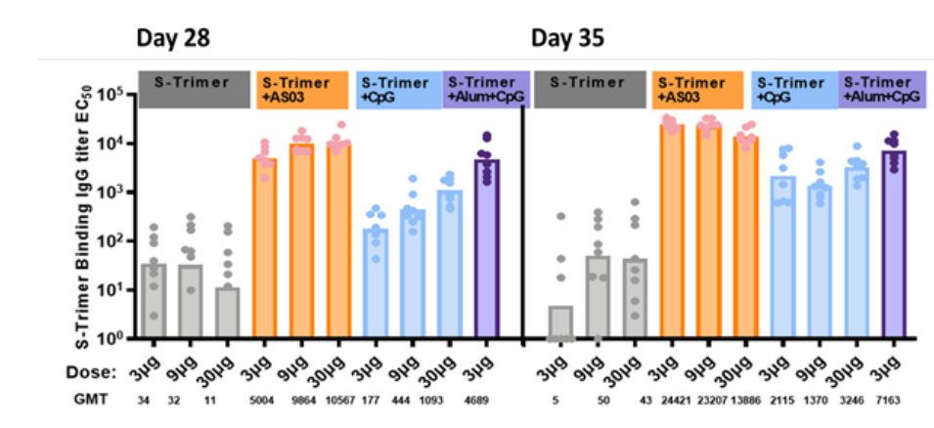  The neutralizing antibody titer was detected by the ACE2-Fc competitive ELISA assay developed by Clover, and the results were consistent with the IgG titer trend, and the Nabs titer produced by the AS03 adjuvant was the highest. The S-Trimer+Alum+CpG combination adjuvant groups also showed consistent neutralizing antibody induction capacity with AS03. In the CpG adjuvant alone group, the competing neutralizing antibody titer is lower, but there is a dose effect. [48]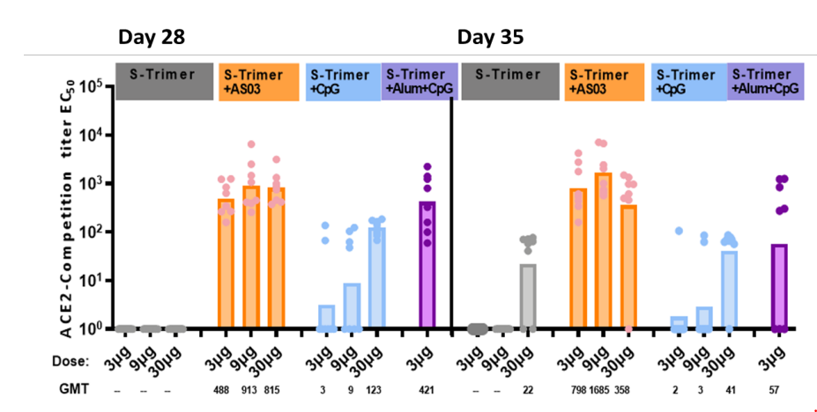  In vitro neutralizing activity titer evaluation with SARS-CoV-2 pseudovirus showed that 3 μg of S-Trimer+AS03 and S-Trimer 3μg+Alum+CpG combination adjuvants were equally effective, with 9 μg of S-Trimer+AS03 being the most effective, and the trend was consistent with our in-house developed competitive neutralizing antibody titers. [48]  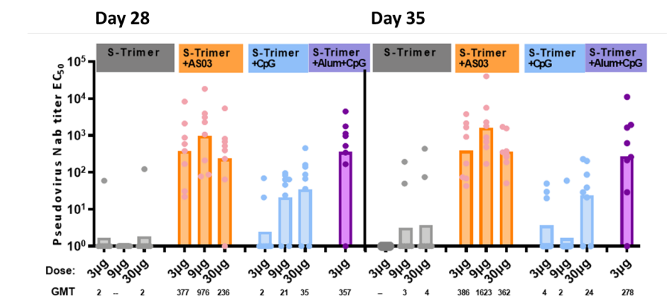  Results from NHP and hamster challenge studies demonstrated that vaccination with SCB‑2019 adjuvanted with CpG 1018/alum induced immune protection from SARS‑CoV‑2 challenge, with no signs of disease enhancement (VAERD or ADE).  In addition, results from a heterologous vaccination study in mice including adenovirus‑vectored COVID‑19 vaccines (AdV) followed by SCB‑2019 vaccine, showed that SCB‑2019 antigen (non‑adjuvanted, CpG/alum‑adjuvanted or alum adjuvanted) induced stronger humoral immune response than homologous primary vaccination series (AdV+AdV). Strong Th1 biased CMI is also maintained with heterologous vaccination series in mice.  CLO‑SCB‑2019‑001 is the first‑in‑human supportive Phase 1 study to assess the safety, tolerability and immunogenicity of multiple dose levels (3 μg, 9 μg and 30 μg) of SCB‑2019 with or without adjuvants in COVID‑19‑negative adults (≥18 to <55 years of age) and healthy elderly subjects (≥55 to ≤75 years of age). Interim results to Day 50 from the initial dose‑escalation phase of the study were supportive of the 30 μg dose and two‑dose primary vaccination regimen given at least 21 days apart selected for SCB‑2019 vaccine . Six‑month results to Day 184 also support the dose and regimen selected. Study CLO‑SCB‑2019‑002 is the 12‑month safety and immunogenicity follow‑up to the Phase 1 study CLO‑SCB‑2019‑001.
5.3 What is the mechanism of action of the adjuvant (if known)? | CpG 1018 is a single stranded 22-base synthetic cytidine-phospho-guanosine phosphorothioate linked oligodeoxynucleotide (CpG-PS ODN) agonist of Toll-Like Receptor 9 (TLR9). CpG 1019 mimics the activity of naturally occurring CpG motifs found in bacterial DNA. CpG 1018 can enhance immune responses in general and tend to promote T-helper type 1 (Th1)-type responses in particular. B cells and plasmacytoid dendritic cells are the main human immune cells that express TLR9. Activation of these cells by CpG 1018 initiates an immunostimulatory cascade that culminates in the indirect maturation, differentiation, and proliferation of natural killer cells, T cells, and monocytes/macrophages that contribute to a Th1-biased immune response.  Aluminium hydroxide has a repository effect to adsorb antigen on the surface and inside aluminum hydroxide-based adjuvant particles, which helps in maintaining physical and chemical characteristics of the antigens. The adjuvant particles submit reposited antigens to the immune cells and promote interactions between antigens and immune cells for long durations to induce immune responses. Aluminium hydroxide also has a pro-phagocytic effect by promoting the uptake of antigen by antigen presenting cells. Aluminum hydroxide can recruit hemocytes, promote dendritic cell (DC) differentiation and accelerate local inflammatory reactions independently of Toll like receptors (TLR). The cellular target bound by aluminium hydroxide include nucleotide binding oligomerization domain (NOD) like receptor protein 3 (NLRP3), through which activates endogenous-cellular immune responses and promote macrophages to secrete high-levels of pro-inflammatory factors such as IL-1β and IL-18. Aluminium hydroxide can prime both Th1 and Th2-type immune responses.
5.4 How is the adjuvant formulated with the antigen? | CpG1018 + Alum Alhydrogel: As a separate extractable solution in a single-use vial + a separate suspension in a vial. [49] [50] [51]
5.5 How might the adjuvant impact the safety profile of the vaccine? | Potential immune-mediated diseases (pIMDs) are a theoretical concern with all adjuvanted vaccines. Based on the theoretical concern that vaccination with an adjuvanted vaccine containing potent immunostimulants may interfere with immunological self-tolerance. pIMDs are AEs of special interest undergoing special safety monitoring for vaccines containing adjuvant systems. pIMDs are a subset of AEs that include autoimmune diseases and other inflammatory and/or neurological disorders of interest which may or may not have an autoimmune etiology. [49] [51]
5.6 Summarize the safety findings (preclinical and clinical) with the adjuvant, formulated with any antigen | CpG1018 + Alum Alhydrogel [52] [53] [54]  - Adjuvanted CpG1018: Animal study shows no vaccine-related serious adverse effects.  - CpG1018 + Alum Alhydrogel : most common local and systemic reactions reported in clinical trials were injection site pain, injection site redness, injection site swelling,  - Most common systemic reaction:  CpG1018: fatigue, headache, malaise, fever and myalgia  Alhydrogel: headache and nausea
6. Delivery and Administration | Information | Comments/ Concerns
6.1 How might the vaccine formulation (antigen and adjuvant already formulated in the same vial or combined prior to administration) impact the safety profile of the vaccine? | CLO-SCB-2019-001 and CLO-SCB-2019-002: SCB-2019 must be mixed with adjuvants (CpG 1018 plus alum Alhydrogel) prior to IM injection in participants.  CLO-SCB-2019-003: SCB-2019 must be mixed with adjuvant prior to IM injection. [49] [50] [51]  See section 5.4.
6.2 If the vaccine is part of a heterologous prime-boost regimen, describe the regimen that this vaccine is a part of and the possible impact on safety | Study Design: This is a multi-center, observer-blind, randomized, controlled phase 3 study to evaluate the immunogenicity and safety of SCB-2019 vaccine administered as a booster dose in individuals who received primary vaccination series with one of the selected COVID-19 vaccines vaccine, ≥3 months prior to enrollment.  Study arms and vaccination schedule:  Stage 1:  Participants who received primary vaccination series with Comirnaty, or CoronaVac [Sinovac COVID-19 Vaccine (Vero Cell) Inactivated] ≥3 months prior to enrollment will be randomized (1:1) to one of the following groups:  • Group 1a (primary series: Comirnaty; N=212): participants will receive one dose of SCB-2019 vaccine on Day 1;  • Group 1b (primary series: Comirnaty; N=212): participants will receive one dose of Comirnaty on Day 1;  • Group 3a (primary series: CoronaVac; N=212): participants will receive one dose of SCB-2019 vaccine on Day 1;  • Group 3b (primary series: CoronaVac; N=212): participants will receive one dose of CoronaVac on Day 1.  Stage 2:  Participants who received primary vaccination series with Vaxzevria ≥3 months prior to enrollment, a will be randomized (1:1) to one of the following groups:  • Group 2a (primary series: Vaxzevria; N=212): participants will receive one dose of SCB-2019 vaccine on Day 1;  • Group 2b (primary series: Vaxzevria; N=212): participants will receive one dose of Vaxzevria on Day 1;  Participants who received primary series and a booster dose of CoronaVac, ≥3 months prior to enrollment will randomized (5:5:2) to one of the last three groups (4a to 4c):  • Group 4a (primary series and booster dose CoronaVac; N=125): participants will receive one dose of SCB-2019 vaccine on Day 1;  • Group 4b (primary series and booster dose CoronaVac; N=125): participants will receive one dose of CoronaVac on Day 1;  • Group 4c (primary series and booster dose CoronaVac; N=50): participants will receive a half dose of SCB-2019 vaccine on Day 1
6.3 Describe how components of the vaccine formulation that facilitate stability and delivery into cells (Section 2.5) may impact the safety profile of the vaccine | Unknown
6.4 Describe how the mode of vaccine delivery may impact safety (e.g., intramuscular by needle injection, microneedles, intranasal, oral) | Intramuscular vaccination commonly precipitates a transient and self-limiting local inflammatory reaction. This may typically include pain, redness, and swelling at the injection site. [49] [51]
* Stability is considered here in the context of any relevant intrinsic characteristic of the vaccine deemed important for safety purpose.
7. Toxicology and Nonclinical | Information | Comments/ Concerns
7.1 What is known about biodistribution of the antigen in its final formulation and mode of administration in animal models? | Biodistribution: Unknown.  Mode of administration: intramuscular (IM) injection. [31]
7.2 How long does the vaccine antigen persist in vivo (may specify in tissue/serum; proximal/distal to site of administration)? | Unknown.
7.3 What is the possible risk of autoimmunity or a harmful immune response? | 1) As Trimer-Tag contains glycine repeats of mature collagen type I, there is a theoretical concern that Trimer-Tag may induce immune response triggering autoimmune disorders or the enhancement of pre-existing immune-mediated diseases. [51]  2) Vaccine-enhanced disease (VED) is a theoretical potential concern with SARS-CoV-2 vaccines. [51]  Refer to 5.5
7.4 Do animal models for toxicity exist? Summarize results | In a repeat-dose toxicology study in rats evaluating unadjuvanted SCB-2019, CpG-1018-adjuvanted SCB-2019 at intended human doses, no mortality nor morbidity occurred in any of the vaccinated animals. No SCB-2019-related findings were observed. Animals receiving SCB-2019 observed transient mild erythema and weakness in hind legs receiving IM injection, as well as transient increases in body temperature after the first dose.  All CpG 1018-related hematology, chemistry, organ weight, and pathology findings recovered or partially recovered after the 4-week recovery period. [31]
7.5 Do animal models for immunogenicity and/or efficacy exist? Summarize results | Preclinical results suggest that SCB-2019 achieves a highly native-like trimeric S-protein structure and could preserve antigenic epitopes critical for neutralizing immunogenicity and potential vaccine efficacy. [31]  SCB-2019 has induced high levels of binding and neutralizing antibodies in multiple animal immunogenicity studies (including mice and NHPs), at levels comparable or higher than in COVID-19 convalescent sera from humans. A type 1 helper cell-biased immune response was observed in mice and NHPs dosed with SCB-2019. [51]
7.6 What is the evidence of disease enhancement (if any) in animal models?* | Results from an NHP challenge study demonstrated that vaccination with SCB-2019 induced immune protection from SARS-CoV-2 challenge, with no signs of VED (i.e., vaccine-associated enhanced respiratory disease or antibody-dependent enhancement). [51]
7.7 Would the vaccine in its final formulation have any impact on innate immunity? If so, what are the implications for benefit-risk? | Unknown
7.8 What is the evidence that the vaccine has generated a beneficial immune response in: | SCB-2019 has induced high levels of binding and neutralizing antibodies in multiple animal immunogenicity studies (including mice and NHPs), at levels comparable or higher than in COVID-19 convalescent sera from humans. A type 1 helper cell-biased immune response was observed in mice and NHPs dosed with SCB-2019. [51]
- Small animal models? | Refer to 7.8.
- Nonhuman primates (NHP)? | Refer to 7.6 & 7.8.
8. Human Efficacy and Other Important Information | Information | Comments/ Concerns
8.1 What is the evidence that the vaccine would generate a protective immune response in humans (e.g., natural history, passive immunization, animal challenge studies)? | The primary objective of the study was met: [1]  - Two doses of SCB-2019 induced protection against COVID-19 of any severity in SARS-CoV-2–naïve adults with an efficacy of 67.2% (95.72% CI: 54.3–76.8).  The pre-specified success criteria were met for three of four key secondary efficacy objectives. [1]  - The efficacy of 2 doses SCB-2019 against moderate-to-severe COVID-19 was 83.7% (97.86% CI 55.9–95.4) in SARS-CoV-2–naïve adults. The pre-specified success criterion (LL of multiplicity-adjusted CI above 0) was met.  - The efficacy of 2 doses SCB-2019 against severe COVID-19 was 100% (97.86% CI 25.3–100.0) in SARS-CoV-2–naïve adults. The pre-specified success criterion (LL of multiplicity-adjusted CI above 0) was met.  - The efficacy of 2 doses SCB-2019 against any laboratory-confirmed SARS-CoV-2 infection was 34.4% (95% CI: 27.1-41.0) in SARS-CoV-2-naïve adults. The pre-specified success criterion (LL of multiplicity-adjusted CI above 0) was met.  - The efficacy of 2 doses SCB-2019 against any laboratory-confirmed asymptomatic SARS-CoV-2 infection was 12.9% (95% CI: -1.4-25.2) in SARS-CoV-2-naïve adults. The pre-specified success criterion (LL of multiplicity-adjusted CI above 0) was not met.  Results from a Non-human primate (NHP) challenge study demonstrated that vaccination with adjuvanted-SCB-2019 (CpG 1018/Alum) induced immune protection from SARS-CoV-2 challenge, with no signs of vaccine-associated enhanced respiratory disease (VAERD) or antibody-dependent enhancement (ADE). [31]
8.2 Describe other key information that may impact benefit-risk | 1) General Risks [49] [51]  - Hypersensitivity including allergic reactions such as anaphylaxis  2) SCB-2019 Vaccine Related Risks [49] [51]  Due to limited experience in human participants, there is not enough information available to identify the risks of uncommon AEs or SAEs related to SCB-2019 vaccine.
9. Adverse Event (AE) Assessment of the Vaccine Platform (*see Instructions): | Information | Comments/ Concerns
9.1 Approximately how many humans have received this vaccine to date? If variants of the vaccine platform, please list separately. ________________ | The SAF adults (including both, Phase 2 and Phase 3 subjects), from Dose 1 up to 1 December 2021 included 15070 adult recipients of at least 1 dose of SCB-2019, and 15067 adult recipients of at least 1 dose of placebo. Of those, 14011 subjects (93.0%) received 2 doses of SCB-2019, and 13861 subjects (92.0%) received 2 doses of placebo.  A total of 1601 subjects participated in Phase 2 part of the study and included in the Phase 2– SAF (Table 66). These subjects were requested to report unsolicited AEs from Day 1 to Day 43 and record solicited AEs within 7 days after each dose, using electronic diary cards. Overall, solicited safety data was available for 99.4% and 99.1% of subjects after the first dose, and 86.9% and 88.1% after the second dose, in SCB-2019 and Placebo arms, respectively. All Phase 2 subjects provided information about unsolicited AEs after the first dose. The proportion of subjects included in the safety analysis sets was similar between SCB-2019 and Placebo arms.
9.2 Method(s) used for safety monitoring:
- Spontaneous reports/passive surveillance | Yes [49] [51] | Protocol CLO-SCB-2019-001 dated 07-Sep-2020 and CLO-SCB-2019-002:  Unsolicited AEs from Day 1 to Day 50 via eDiary  Protocol CLO-SCB-2019-003:  Immunogenicity/reactogenicity subset (total of 1200 subjects): unsolicited AEs will be collected from Day 1 to Day 43.
- Diary | Yes [49] [51] | Protocol CLO-SCB-2019-001 dated 07-Sep-2020 and CLO-SCB-2019-002: 50 days  Protocol CLO-SCB-2019-003:  All subjects: AEs will be collected after each study vaccination via e-diary, and all SAEs, AEs leading to early study termination, MAAEs, and AESIs will be collected during the entire study period (until the end of the study – approximately 389 days).
- Other active surveillance | Yes [49] | Protocol CLO-SCB-2019-001 dated 07-Sep-2020 and CLO-SCB-2019-002:  Subjects will be instructed to measure and record oral body temperature and any solicited local/general AEs for 7 days after each dose of the study vaccine/placebo
9.3 What criteria were used for grading the AEs?
- 2007 US FDA Guidance for Industry Toxicity Grading Scale for Healthy Adult and Adolescent Volunteers Enrolled in Preventive Vaccine Clinical Trials | Yes [49] [50] [51]
- If no criteria were used for grading, or if other metrics were employed, please describe: | N/A
9.4 List and provide frequency of any or possibly related serious* AEs and well as any severe expected or unexpected AEs observed: (*see Instructions): | Solicited Local Adverse Events (Phase 2 SAF)  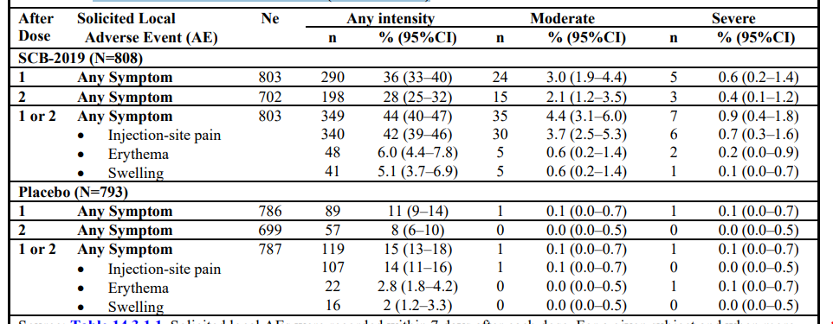  Solicited Systemic Adverse Events (Phase-2 SAF)  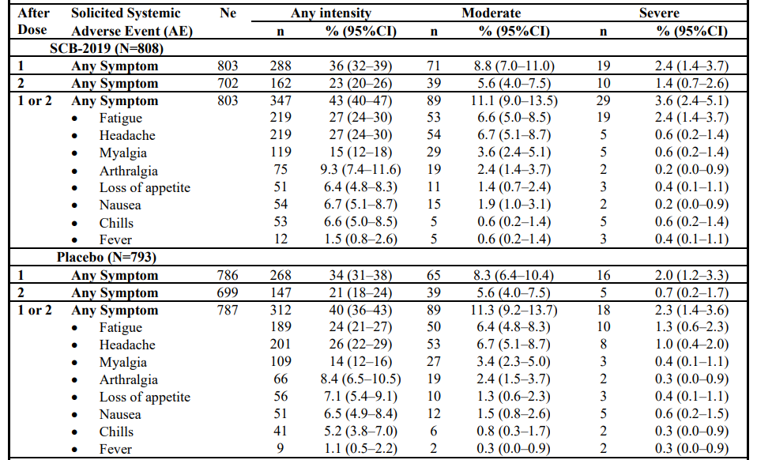  Unsolicited AEs in the Phase 2 SAF (Day 1 to 43)  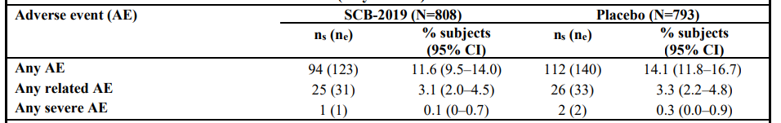  Unsolicited AEs with prevalence of >1% subjects by SOC in the Phase 2 SAF (Day 1 to 43)  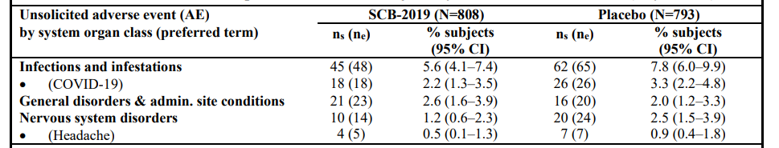  Related unsolicited AEs with prevalence of >0.5% subjects by SOC in the Phase 2 SAF (Day 1 to 43)  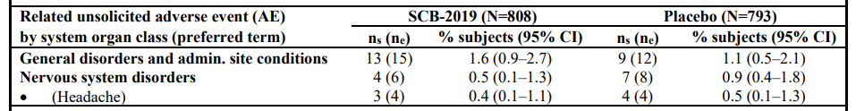
9.5 List and provide frequency of any serious, unexpected significantly increased AE or lab abnormality in vaccine vs. control groups: | The frequency of AE are comparable in vaccine & control group, there is no significant increase here.
- Describe the control group: __________. | Control group for Protocol CLO-SCB-2019-001 and  Protocol CLO-SCB-2019-003: subjects will receive placebo [49] [50] [51]  Control group for Protocol CLO-SCB-2019-002 dated 03-Jun-2020: Nil
9.6. List and provide frequency of Adverse Events of Special Interest | Overall Summary of Unsolicited AEs, SAEs MAAEs, AESIs and AEs Leading to Study Termination (SAF)  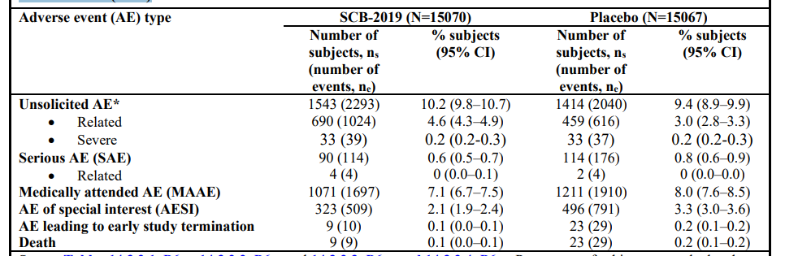
9.7 What is the evidence of disease enhancement (if any) in humans? | No evidence of disease enhancement has been observed.
9.8 Did a Data Safety Monitoring Board (DSMB) or its equivalent oversee the study? | Yes [49] [51]
- Did it identify any safety issue of concern? | No safety issues of concern have been identified by the DSMB.
- If so describe:
10. Overall Risk Assessment | Information | Comments/ Concerns
10.1 Please summarize key safety issues of concern identified to date, if any: | None currently. Study is ongoing. Interim analysis is planned at a later this year.
- how should they be addressed going forward | None currently. Study is ongoing. Interim analysis is planned at a later this year.
10.2 What is the potential for causing serious unwanted effects and toxicities in: | Describe the toxicities | Please rate risk as:  none, minimal, low, moderate, high, or unknown
- healthy humans? | - In the Phase-2 SAF, and within the 7-day periods after either dose, solicited local AEs were reported by 44% (349/803) of SCB-2019 recipients and 15% (119/787) of placebo recipients. Solicited systemic AEs were reported by 43% (347/803) of SCB-2019 recipients and 40% (312/787) of placebo recipients.  - In the Phase-2 SAF, and within the 6-week period after receiving the 1st dose, unsolicited AEs were reported by 12% (94/808) of SCB-2019 recipients and 14% (112/793) of placebo recipients. Related unsolicited AEs (i.e., unsolicited AEs considered by the investigator as related to vaccination were reported by 3.1% (25/808) of SCB-2019 recipients and 3.3% (26/793) of placebo recipients.  - In the SAF, from Dose 1 to 3-weeks after Dose 2 (Day 43), unsolicited AEs were reported by 10.2% (1543/15070) of SCB-2019 recipients and 9.4% (1414/15067) of placebo recipients. Related unsolicited AEs (i.e. unsolicited AEs considered by the investigator as related to vaccination) were reported by 4.6% (690/15070) of SCB-2019 recipients and 3.0% (459/15067) of placebo recipients.  - From Dose 1 to 1 December 2021, 114 SAEs were reported by 0.6% (90/15070) of SCB-2019 recipients and 176 SAEs were reported by 0.8% (114/15067) of placebo recipients. Nine deaths were reported among SCB-2019 recipients, and 23 deaths were reported among placebo recipients. Four related SAEs were reported by four SCB-2019 recipients, and four related SAEs were reported by two placebo recipients.  - From Dose 1 to 1 December 2021, MAAEs were reported by 7.1% (1071/15070) of SCB 2019 recipients and 8.0% (1211/15067) of placebo recipients (Table 68). AESIs were reported by 2.1% (323/15070) of SCB-2019 recipients and 3.3% (496/15067) of placebo recipients. AEs leading to early study termination were reported by 0.1% (9/15070) of SCB 2019 recipients and 0.2% (23/15067) of placebo recipients.  - Overall, a lower proportion of subjects experienced SAEs, MAAEs and AESIs with SCB-2019 than with placebo. | Minimal [49] [50] [51]
- immunocompromised humans? | N/A | N/A
- human neonates, infants, children? | N/A | N/A
- pregnancy and in the fetus in humans? | The follow-up is still ongoing. | N/A
- elderly? | N/A | Minimal [49] [51] [50]
- in any other special populations (e.g., institutionalized population, individuals with associated chronic comorbidity)? | Study is ongoing. Interim analysis is planned at a later this year. | N/A

Bibliography

[1] | Clover, "CLO-SCB-2019-003-compiled CSR V1.0," 11 November 2022. [Online].
[2] | L. Bravo, "Efficacy of the adjuvanted subunit protein COVID-19 vaccine, SCB-2019: a phase 2 and 3 multicentre, double-blind, randomised, placebo-controlled trial," Lancet, vol. 399, no. 10323, pp. 461-472, 2022.
[3] | E. Buntinx, "Immunogenicity of an adjuvanted SARS-CoV-2 trimeric S-protein subunit vaccine (SCB-2019) in SARS-CoV-2-naïve and exposed individuals in a phase 2/3, double-blind, randomized study," Vaccine, vol. 41, no. 11, pp. 1875-1884, 2023.
[4] | R. Hosain, "Six-month safety follow-up of an adjuvanted SARS-CoV-2 trimeric S-protein subunit vaccine (SCB-2019) in adults: A phase 2/3, double-blind, randomized study.," Vaccine, vol. 41, no. 13, pp. 2253-2260, 2023.
[5] | J. Bonhoeffer, "The Brighton Collaboration: addressing the need for standardized case definitions of adverse events following immunization (AEFI)," vol. 21, no. 3-4, pp. 298-302, 2002.
[6] | S. Kochhar, "The Brighton Collaboration standardized template for collection of key information for benefit-risk assessment of protein vaccines," vol. 38, no. 95, pp. 5734-5739, 2020.
[7] | R. Chen, "The Brighton Collaboration Viral Vector Vaccines Safety Working Group (V3SWG)," Vaccine, vol. 33, no. 1, pp. 73-75, 2015.
[8] | WHO, "Weekly Epidemiological Record No. 28," Online Print, vol. 94, pp. 310-312, 2019.
[9] | WHO, "Weekly Epidemiological Record. No. 4," Online Print, vol. 95, pp. 29-30, 2020.
[10] | L. Rouijan, "Genomic characterisation and epidemiology of 2019 novel coronavirus: implications for virus origins and receptor binding," Lancet, vol. 395, no. 10224, pp. 565-574, 2020.
[11] | T. Kuo, "Development of CpG-adjuvanted stable prefusion SARS-CoV-2 spike antigen as a subunit," Sci Rep, vol. 10, no. 1, p. 20085, 2020.
[12] | WHO, "Weekly epidemiological update on COVID-19 - 30 November 2022," 30 November 2022. [Online].
[13] | WHO, "WHO Interim Guidance 2020," 2020. [Online]. Available: https://www.who.int/publications/i/item/WHO-2019-nCoV clinical-2021-1.
[14] | G. Rego, "Current clinical trials protocols and the global effort for immunization against SARS-CoV-2," Vaccines (Basel), vol. 8, no. 3, p. 474, 2020.
[15] | G. Forni, "COVID-19 vaccines: where we stand and challenges ahead," Cell Death Differ, vol. 28, no. 2, pp. 626-39, 2021.
[16] | N. Wang, "ubunit vaccines against emerging pathogenic human coronaviruses," Fron Microbiol, vol. 11, no. 298, 2020.
[17] | P. Zhou, "a pneumonia outbreak associated with a new coronavirus of probable bat origin.," Nature, vol. 579, no. 7798, pp. 270-3, 2020.
[18] | D. Wrapp, "Cryo-EM structure of the 2019-nCoV spike in the prefusion conformation," Science, vol. 367, no. 6483, pp. 1260-3, 2020.
[19] | A. Walls, "Structure, fuction, and antigenicity of the SARS-CoV-2 spike glycoprotein," Cell, vol. 181, no. 2, pp. 282-92, 2020.
[20] | S. Belouzard, "Mechanisms of coronavirus cell entry mediated by the viral spike protein," Viruses, vol. 4, no. 6, pp. 1011-33, 2012.
[21] | W. Li, "Angiotensin-converting enzyme 2 is a functional receptor for the SARS coronavirus," Nature, vol. 426, no. 6965, pp. 450-4, 2003.
[22] | I. Hamming, "Tissue distribution of ACE2 protein, the functional receptor for SARS coronavirus. A first step in understanding SARS pathogenesis," J Pathol, vol. 203, no. 2, pp. 631-7, 2004.
[23] | B. Graham, "Rapid COVID-19 vaccine development," Science, vol. 368, no. 6494, pp. 945-6, 2020.
[24] | P. Richmond, "Safety and immunogenicity of S-Trimer (SCB-2019), a protein subunit vaccine candidate for COVID-19 in healthy adults: a phase 1, randomised, double-blind, placebo-controlled trial.," Lancet, vol. 397, no. 10275, pp. 682-695, 2021.
[25] | C. Bode, "CpG DNA as a vaccine adjuvant," Expert Rev Vaccines, vol. 2, no. 2, pp. 499-511, 2011.
[26] | D. Toussi, "Immune adjuvant effect of mplecularly-defined toll-like receptor ligands," Vaccines (Basel), vol. 2, no. 2, pp. 323-353, 2014.
[27] | H. Hogenesch, "Mechanism of immunopotentiation and safety of aluminum adjuvants," Front Immunol, vol. 3, no. 406, 2013.
[28] | B. Guy, "The perfect mix: recent progress in adjuvant research," Nat Rev Microbiol, vol. 5, no. 7, pp. 505-517, 2007.
[29] | H. Davis, "CpG DNA is a potent enhancer of specific immunity in mice immunized with recombinant hepatitis B surface antigen," J Immunol, vol. 160, no. 2, pp. 870-6, 1998.
[30] | C. Cooper, "CPG 7909, an immunostimulatory TLR9 agonist oligodeoxynucleotide, as adjuvant to Engerix-B HBV vaccine in healthy adults: a double-blind phase I/II study," J Clin Immunol, vol. 24, no. 6, pp. 693-701, 2004.
[31] | SCB, "SCB-2019 Investigator’s Brochure Version 5.0," 2020.
[32] | WHO, "Coronavirus disease (COVID-19)," 09 08 2023. [Online]. Available: https://www.who.int/news-room/fact-sheets/detail/coronavirus-disease-%28covid-19%29. [Accessed 2024].
[33] | K. Lang, "What do we know about covid in immunocompromised people?," BMJ, vol. 383, p. 1612, 2023.
[34] | S. L. a. X. Sun, "COVID-19 in Early Life: Infants and Children Are Affected Too," Physiology (Bethesda), vol. 36, no. 6, pp. 359-366, 2021.
[35] | M. Clinic, "Pregnancy and COVID-19: What are the risks?," 05 04 2024. [Online]. Available: https://www.mayoclinic.org/diseases-conditions/coronavirus/in-depth/pregnancy-and-covid-19/art-20482639. [Accessed 2024].
[36] | C. Wei, "Clinical characteristics and manifestations in older patients with COVID-19," BMC Geriatrics, vol. 20, no. 395, 2020.
[37] | B. Hu, "Characteristics of SARS-CoV-2 and COVID-19," Nat Rev Microbiol, vol. 19, no. 3, pp. 141-154, 2021.
[38] | M. Lotfi, "COVID-19: Transmission, prevention, and potential therapeutic opportunities," Clin Chim Acta, vol. 508, pp. 254-266, 2020.
[39] | WHO, "Coronavirus disease (COVID-19): How is it transmitted?," 23 12 2021. [Online]. Available: https://www.who.int/news-room/questions-and-answers/item/coronavirus-disease-covid-19-how-is-it-transmitted. [Accessed 2024].
[40] | Y. Wu, "Incubation Period of COVID-19 Caused by Unique SARS-CoV-2 Strains," JAMA, vol. 5, no. 8, p. e2228008, 2022.
[41] | Z. Karimizadeh, "The reproduction rate of severe acute respiratory syndrome coronavirus 2 different variants recently circulated in human: a narrative review," Eur J Med Res, vol. 28, no. 94, 2023.
[42] | S. Manathunga, "A comparison of transmissibility of SARS-CoV-2 variants of concern," Virology, vol. 20, no. 59, 2023.
[43] | X. Xu, "Assessing changes in incubation period, serial interval, and generation time of SARS-CoV-2 variants of concern: a systematic review and meta-analysis," BMC Medicine, vol. 21, no. 374, 2023.
[44] | WHO, "COVID-19 epidemiological update – 15 March 2024," 15 03 2024. [Online]. Available: https://www.who.int/publications/m/item/covid-19-epidemiological-update-15-march-2024. [Accessed 2024].
[45] | COVID-19 and Older Adults: What We Know. J Am Geriatr Soc. 2020 May; 68(5): 926–929. Published online 2020 Apr 20. doi: 10.1111/jgs.16472
[46] | M. Rokni, "Immune responses and pathogenesis SARS-CoV-2 during an outbreak in Iran: Comparison with SARS and MERS," Rev Med Virol, 2020.
[47] | X. Fang, "Epidemiological, comorbidity factors with severity and prognosis of COVID-19: a systematic review and meta-analysis," Aging, vol. 12, no. 13, pp. 12493-12503, 2020.
[48] | J. Ma, "Cryo-EM structure of S-Trimer, a subunit vaccine 1 candidate for 2 COVID-19," bioRxiv, 2020.
[49] | SCB, "Protocol CLO-SCB-2019-001 dated 07-Sep-2020," 2020.
[50] | SCB, "Protocol CLO-SCB-2019-002 dated 03-Jun-2020," 2020.
[51] | SCB, "Protocol CLO-SCB-2019-003 dated 30-Sep-2020," 2020.
[52] | Clover, "Package insert: HEPLISAV-B".
[53] | T. Kuo, "Development of CpG-adjuvanted stable prefusion SARS-CoV-2 spike antigen as a subunit vaccine against COVID-19," bioRxiv, 2020.
[54] | M. Roestenberg, "Safety and immunogenicity of a recombinant Plasmodium falciparum AMA1 malaria vaccine adjuvanted with Alhydrogel, Montanide ISA 720 or AS02," PLoS One, vol. 3, no. 12, p. e3960, 2008.
[55] | WHO, "Novel Coronavirus(2019-nCoV) Situation Report – 22," 11 02 2020. [Online]. Available: https://www.who.int/docs/default-source/coronaviruse/situation-reports/20200211-sitrep-22-ncov.pdf.

